**Global shark attacks analysis**

Why can’t we help but have the JAWS theme song lingering in our heads when we enter into the water of an isolated beach? It is inevitable that sharks are often pictured as the terror itself and shark attacks attract high level of media and public attention and often have serious consequences for those attacked.

In the last decade there has been xxx cases recorrded, but the real question is what is the probability of being attacked by a shark given the high number of people that uses the ocean every year?

Thankfully, we have records of shark attacks since the early days, so I have focused in analyzing data from the 1800 to 2018 with the purpose to answer this question, and also explain the patterns of shark attacks worldwide, examine how this has changed over time and country, identify factors that may help reduce the incidence of attacks and contribute to our understanding of shark behaviour.

In order to answer this questions and other hypothesis I have used TABLEAU to visualize the data and python to develop some statistical tests.

The first insights that we retrieve from the data visualization is that shark attacks **clearly increase** over the years, but with a similar death ratio. This is probably due to increasing human population, more people visiting beaches, a rise in the popularity of water-based activities etc. and because the quality of shark attack recording has leveled up with the pass of the years.

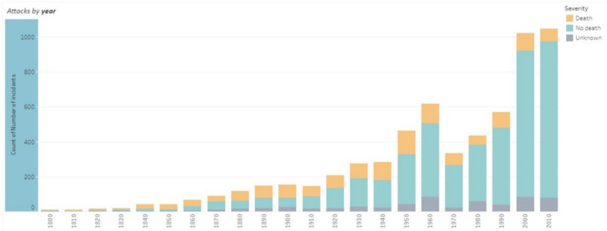Shark attacks by **year**

If we take a look at the age distribution of the victims we can clearly see that sharks prefer youngsters, and the vast majority of the victims are aged between 15 and 25. When it comes to gender males are first in sharks feeding chain wya ahead of females, and the death ratio is also higher amongst man.

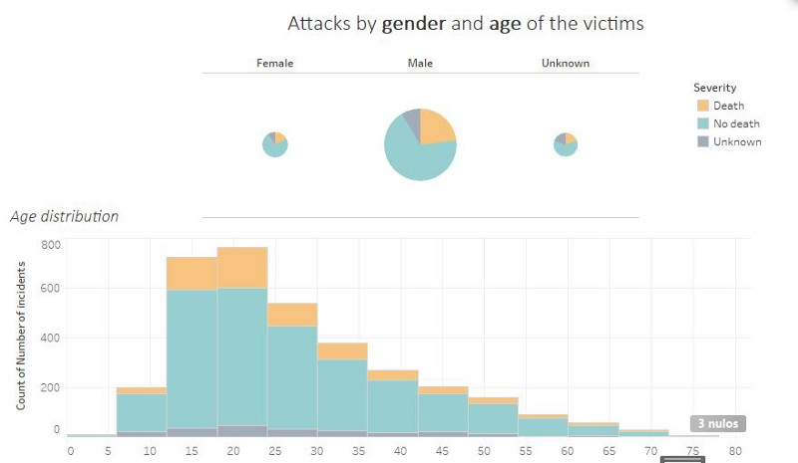

We